DATABASE SYSTEMS LAB REPORT

NAME:
Zahra sadaf

ROLL NO:
2026SCS-47

SECTION:
A

SUBMITTED TO:
SIR WALEED



Contents
Lab 01: Installation and Configuration of MySQL 3
Lab Objectives 3
Creation of Tables 4
Insertion of Data 5
Viewing Table Structures 7
Sample Table Structures 7
Customers 7
Products 7
Orders 8
Browsing Table Data 8
Database Export 9
Home Task Part 1 — TestDB_2026_CS_11 10
Creation of Student Table 10
Inserting Student Data 11
Generating Database Scripts 12
Home Task Part 2 13
Table Structures for Home Task 13
Sample Data for Home Task 14
Conclusion 14

Table of figures:
Figure 1 SHOW TABLES 5
Figure 2 SELECT * FROM 6
Figure 3 SELECT * FROM 6
Figure 4 SELECT * FROM 7
Figure 5 Seclect * from limit 9
Figure 6 Student Table Structure 11
Figure 7 SELECT * FROM 12
Lab 01: Installation and Configuration of MySQL

Lab Objectives

The objectives of this lab are:

- To install and configure MySQL Server and MySQL Workbench.
- To create and manage a MySQL database.
- To create tables using SQL commands.
- To insert and view data in tables.
- To understand database schema and table structure.
- To export a database.
- To create a MySQL user and assign privileges.
- To understand the process of connecting to a MySQL database.

Creation of "first_lab" Database

A database named "first_lab" was created using the following SQL command:

CREATE DATABASE first_lab;

The database was then selected using:

USE first_lab;

The database was verified using:

SHOW DATABASES;

Creation of Tables

Five tables were created inside the "first_lab" database:

- Customers
- Categories
- Products
- Employees
- Orders

The tables were created using SQL commands with appropriate primary and foreign keys.

For example, the "Customers" table was created as:

CREATE TABLE Customers
(
CustomerID INT PRIMARY KEY,
CustomerName VARCHAR(45) NOT NULL,
ContactName VARCHAR(45),
Country VARCHAR(45)
);

The "Products" table contains a foreign key that connects it with the "Categories" table.

The "Orders" table contains foreign keys connecting it with Customers, Products, and Employees.

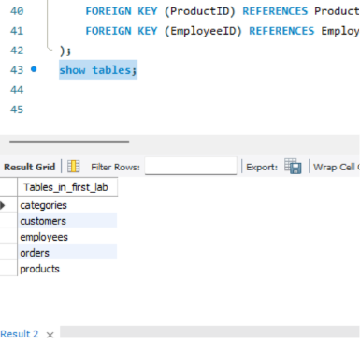

Figure 1 SHOW TABLES

Insertion of Data

Sample data was inserted into all five tables.

The following tables were populated:

- Customers
- Categories
- Products
- Employees
- Orders

For example:

INSERT INTO Customers
VALUES
(1, 'Ali Khan', 'Ahmed Ali', 'Pakistan'),
(2, 'Usman Ahmed', 'Usman Ahmed', 'Pakistan'),
(3, 'Hamza Malik', 'Hamza Malik', 'UAE'),
(4, 'Bilal Shah', 'Bilal Shah', 'Pakistan'),
(5, 'Hassan Raza', 'Hassan Raza', 'Saudi Arabia');

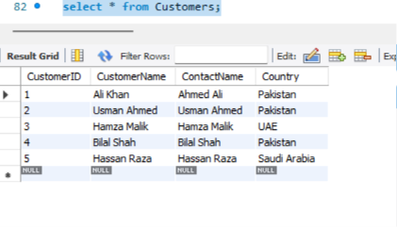
Figure 2 SELECT * FROM

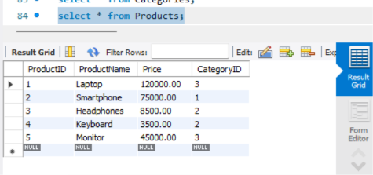
Figure 3 SELECT * FROM

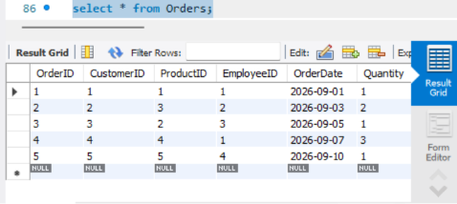
Figure 4 SELECT * FROM

Viewing Table Structures

The structure of the tables was checked using the "DESCRIBE" command.

For example:

DESCRIBE Customers;

The command displays the field name, data type, NULL property, key, default value, and extra information.

Sample Table Structures

Customers

Field| Data Type| Key/Constraint
CustomerID| INT| Primary Key
CustomerName| VARCHAR(45)| NOT NULL
ContactName| VARCHAR(45)| —
Country| VARCHAR(45)| —

Products

Field| Data Type| Key/Constraint
ProductID| INT| Primary Key
ProductName| VARCHAR(100)| NOT NULL
Price| DECIMAL(10,2)| —
CategoryID| INT| Foreign Key

Orders

Field| Data Type| Key/Constraint
OrderID| INT| Primary Key
CustomerID| INT| Foreign Key
ProductID| INT| Foreign Key
EmployeeID| INT| Foreign Key
OrderDate| DATE| —
Quantity| INT| —

Browsing Table Data

The data stored in the tables was viewed using the following SQL command:

SELECT * FROM Customers;

Similarly, the data from other tables was displayed using "SELECT" statements.

Three sample rows from the Customers table are:

CustomerID| CustomerName| ContactName| Country
1| Ali Khan| Ahmed Ali| Pakistan
2| Usman Ahmed| Usman Ahmed| Pakistan
3| Hamza Malik| Hamza Malik| UAE

Three sample rows can also be obtained using:

SELECT * FROM Customers LIMIT 3;

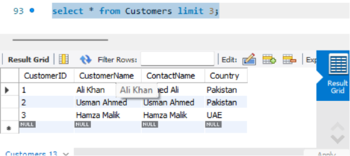
Figure 5 Seclect * from limit

Database Export

The database was exported using MySQL Workbench.

The following procedure was used:

- Opened Server.
- Selected Data Export.
- Selected the required database.
- Selected Export to Self-Contained File.
- Selected Dump Structure and Data.
- 6. Selected the location for the SQL file.
- Started the export.

The exported file contains the database structure and data.

Home Task Part 1 — TestDB_2026_CS_47

A database named:

TestDB_2026_CS_47

was created.

CREATE DATABASE TestDB_2026_CS_47;
USE TestDB_2026_CS_47;

Creation of Student Table

A "student" table containing six attributes was created.

CREATE TABLE student
(
StudentID INT PRIMARY KEY,
StudentName VARCHAR(100),
FatherName VARCHAR(100),
Age INT,
Department VARCHAR(50),
CGPA DECIMAL(3,2)
);

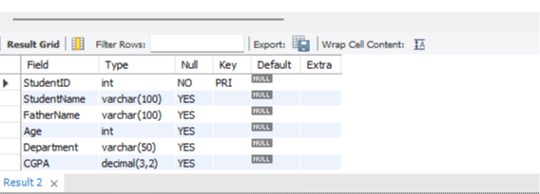
Figure 6 Student Table Structure

Inserting Student Data

Five student records were inserted:

StudentID| StudentName| FatherName| Age| Department| CGPA
1| Ali| Ahmed| 20| Computer Science| 3.50
2| Usman| Khan| 21| Computer Science| 3.20
3| Hamza| Rashid| 20| Electrical Engineering| 3.70
4| Bilal| Aslam| 22| Computer Science| 3.10
5| Hassan| Malik| 21| Software Engineering| 3.80

The records were verified using:

SELECT * FROM student;

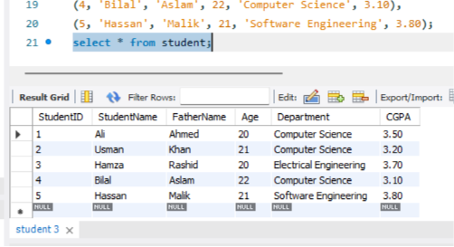
Figure 7 SELECT * FROM

Generating Database Scripts

The database was exported using MySQL Workbench's Data Export functionality.

A schema/structure script was generated for:

TestDB_2026_CS_11

The script was saved as:

TestDB_2026_CS_11_schema.sql

A separate data script was also generated:

TestDB_2026_CS_11_data.sql

Home Task Part 2

The "first_lab" database was selected:

USE first_lab;

All tables were displayed using:

SHOW TABLES;

The tables were:

- Customers
- Categories
- Products
- Employees
- Orders

The lab instructions require listing tables, viewing table structures, browsing data, and documenting sample records.

Table Structures for Home Task

The structures of the following tables were inspected:

- Customers
- Products
- Orders

The following commands were used:

DESCRIBE Customers;
DESCRIBE Products;
DESCRIBE Orders;

Sample Data for Home Task

Three sample rows were obtained from the important tables using:

SELECT * FROM Customers LIMIT 3;

SELECT * FROM Products LIMIT 3;

SELECT * FROM Orders LIMIT 3;

Conclusion

In this lab, MySQL Server and MySQL Workbench were configured and used to perform basic database management tasks.

A database named "first_lab" was created along with multiple related tables. Data was inserted and retrieved using SQL commands. Table structures were examined using the "DESCRIBE" command.

For the home task, the "TestDB_2026_CS_11" database and "student" table were created, populated, and prepared for schema and data export.

Overall, the lab provided practical experience with MySQL database creation, table creation, data manipulation, database inspection, export, and user privileges.

